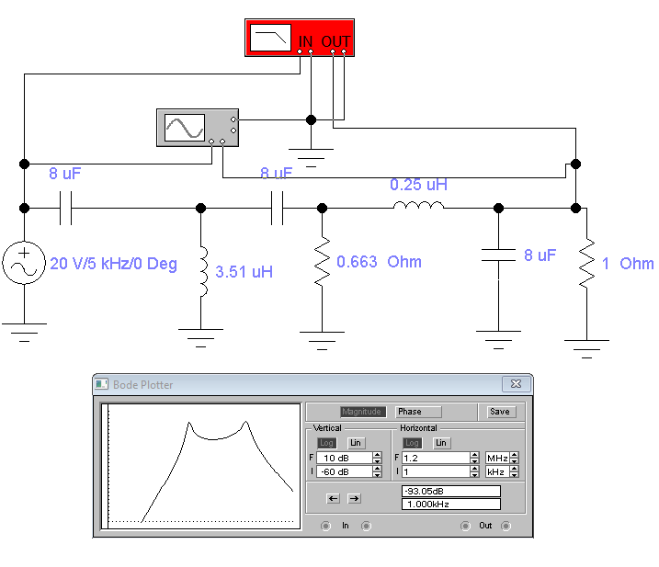

|  |  |  |  |  |
| --- | --- | --- | --- | --- |
| Var | 3 | | | |
|  | f1 | f2 | a | b |
|  | 30000 | 145000 | 60 | 40 |

|  |  |  |
| --- | --- | --- |
| Calcs | | |
| Name | Formula | Result |
| omega | 2*Pi*f | 188495.5592 |
| Xc1 | 1/(omega*C) | 0.663145596 |
| C1 | Rand | 0.000008 |
| Xl1 | omega*L | 0.663145596 |
| L1 | Xl1/omega | 3.5181E-06 |
| R1 | Xc1 | 0.663145596 |
|  |  |  |
| omega2 | 2*pi*f2 | 911061.8695 |
| Xc2 | 1/(omega2*C) | 0.137202537 |
| C2 | Rand | 0.000008 |
| XL | Xc | 0.137202537 |
| L | XC/omega2 | 1.50596E-07 |